Phrases to talk about the materials:
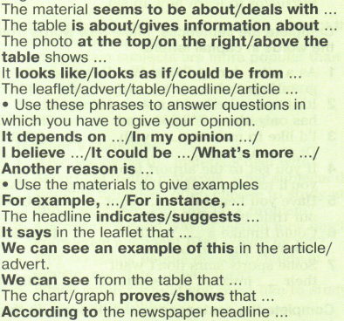
________________________________________________________________________________
Phrases to talk about the materials:
________________________________________________________________________________
Phrases to talk about the materials:
________________________________________________________________________________
Phrases to talk about the materials:

